ASE CHEAT SHEET

**10/ Sealed Classes:**

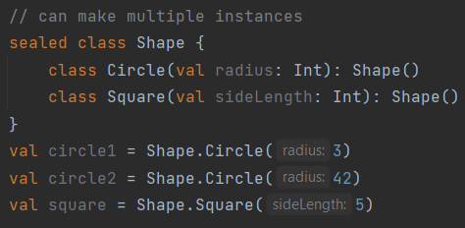

**7/ Data class:**

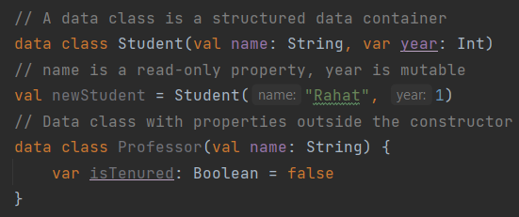

**9/ Generate random string:**

private fun getRandomString(length: Int) : String {  
 val charset = "ABCDEFGHIJKLMNOPQRSTUVWXTZabcdefghiklmnopqrstuvwxyz0123456789"  
 return (1..length)  
 .*map* **{** charset.*random*() **}** .*joinToString*("")  
}

**8/ Encryption-decryption library:**

com.scottyab.aescrypt.AESCrypt

**5/ Pass value through activity:**

**Send:**

intent.putExtra(“key”, “value”)

**Receive:**

var data = *intent*.getStringExtra(“key”)

**6/ Four phases of scrum:**

1. Backlog

2. Sprint

3. Scrum meeting

4. Demos

**4/ DRY: Don't Repeat Yourself:**

It states that every piece of knowledge must have a single, unambiguous, authori-tative representation within a system (codebase).

**2/ Sandi Metz’s Rules:**

1. Classes can be no longer than 100 lines of code.
2. Methods can be no longer than 5 lines of code.
3. Pass no more than 4 parameters into a method.
4. Controllers can instantiate only one object.

**3/ Code smells:**

1. **Rigidity:** The software is difficult to change
2. **Fragility:** The software breaks in many places due to a single change.
3. **Immobility:** You cannot reuse parts of the code in other projects because of involved risks and high effort.
4. **Needless Complexity**.
5. **Needless Repetition.**
6. **Opacity:** The code is hard to understand.

**1/ Seven tips for clean code:**

1. Use proper naming convention.
2. Write short functions that only do one thing.
3. Write good documentation.
4. Be Consistent.
5. Encapsulation + Modularization.
6. Follow Sandi Metz’s Rules.
7. Follow DRY Principle.